Table of Contents

Guest: 3

Login/Log Out: 4

Login: 5

Log out: 6

Customer: 7

Change Password: 7

Order Table: 10

Orderr table: 11

Cancel Ordering Table: 12

Order Food 12

Feedback 14

Staff: 15

Change Password: 16

Manage Order Food: 17

Edit Confirm: 17

Delete Ordering Food: 18

Manage Order Table: 19

Edit Confirm: 20

Delete Ordering Table: 21

Manage Feedback: 22

Admin: 23

Manage Staff: 24

Insert Staff: 24

Delete Staff: 26

Manage restaurant: 27

Insert restaurant: 27

Edit Restaurant: 29

Change Status restaurant: 31

Manage Room: 32

Insert table: 32

Edit table: 34

Change Status table: 35

Manage Room: 35

Change Status table: 36

Manage Category Food: 36

Insert Category Food: 37

Manage Room: 38

Change Status table: 39

Manage Category Food: 39

Insert Category Food: 40

Edit Category Food: 41

Change Status Category Table: 42

Manage Food: 42

Insert Food: 44

Edit Category Food: 45

Change Status Food: 47

Manage Customer: 48

**Case and Sequence Diagram Use**

# Guest:

|  |  |  |
| --- | --- | --- |
| **Use Case Name** | Register user | |
| **Actors** | Guest | |
| **Description** | Guest wants to register with the website to become a customer. | |
| **Requirements** | Guest provides Guest’s information | |
| **Pre-conditions** |  | |
| **Post-conditions** | Success: Guest creates a account in this website  Fail: Refill information | |
| **Basic flow** | Actor Actions:  1. Actor clicks ‘Register’ link in Home page  3. Actor inputs register’s information and  click ‘Register’ button. | System Responses:  2. System redirects to Register page and displays Registration form with the following control :  - ‘UserName’ text field  - ‘Password’ text field  - ‘Confirm Password’ text field  - ‘Name’ text field  - ‘Address’ text field  - ‘Phone’ text field  - ‘Email’ text field  - ‘Register’ button  - ‘Cancel’ button  4. System checks the information  [Exception]  5. System inserts the account into database, show message: ‘Your account has been created!’ and then redirects to Login page. |
| **Exception** | Actor Actions: [Exception]  blank.   1. Actor lefts ‘UserName’ text field ‘Email is invalid’ 2. UserName has already exists. 3. Actor lefts ‘Password’ text field blank. 4. Actor lefts ‘Confirm Password’ text field blank. 5. Password and confirm password don’t match. 6. Actor lefts ‘Name’ text field blank. 7. Actor lefts ‘Address’ text field blank. 8. Actor lefts ‘Phone’ text field blank. 9. Input phone not in numeric or phone length not in range 10 – 11 character. 10. Actor lefts ‘Email’ text field blank or 11. input an invalid email address. | System Responses:  System displays message to Actor :   * ‘UserName cannot be blank’. * ‘This Username has already exist!’. * ‘Password cannot be blank’’. * ‘Confirm Password can’t be blank’. * ‘Confirm password not match password.’ * ‘Name cannot be blank’. * ‘Address cannot be blank’. * ‘Phone cannot be blank’. * - ‘The phone number should be numeric only and must be between 10 and 11 digits’. |

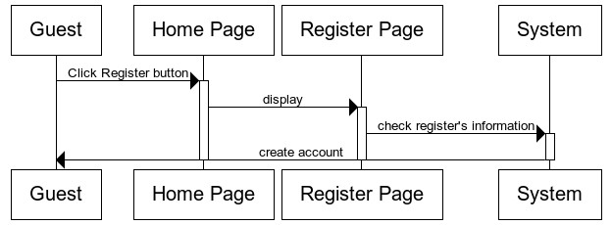

## Login/Log Out:

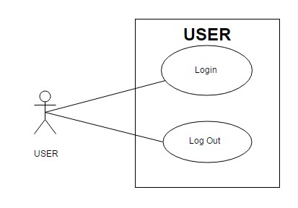

## Login:

|  |  |  |
| --- | --- | --- |
| **Use Case Name** | Login | |
| **Actors** | Customer, Admin or Staff. | |
| **Description** | Customer, Admin or Staff wants to login to website. | |
| **Requirements** | Actor provides username and password | |
| **Post-conditions** | Success: User logged in to website.  Fail: Refill information | |
| **Basic flow** | * Actor Actions: * Actor go to Home page of website. * Actor inputs UserName and * Password, then click the Login button. | * System Responses: * 2. System redirects to Home page and displays Login form on the left with the following control: * ‘UserName’ text field * ‘Password’ text field * ‘Login’ button * ‘Cancel’ button * 4. System checks the information * 5. System redirects to Actor’s Home * page. |
| **Exception** | * Actor Actions: * [Exception] * 1. Actor input invalid username and password. | * System Responses: * - System redirect to Login page with the following controls: * - ‘UserName’ text field * - ‘Password’ text field * - ‘Login’ button. * - ‘Cancel’ button. * System show a message box: “Invalid * Username and password”. |

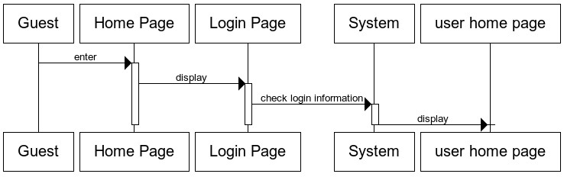

## Log out:

|  |  |  |
| --- | --- | --- |
| **Use Case Name** | Log out | |
| **Actors** | Customer, Admin or Staff. | |
| **Description** | Customer, Admin or Staff wants to log out of the System. | |
| **Pre-conditions** | Actor has logged in. | |
| **Post-conditions** | Success: Actor Logged out. | |
| **Basic flow** | Actor Actions:  1. Actor clicks ‘Log out’ button on the  Actor’s Home menu. | System Responses:  2. System redirect to Logout page, remove session, and then redirect to Login page. |

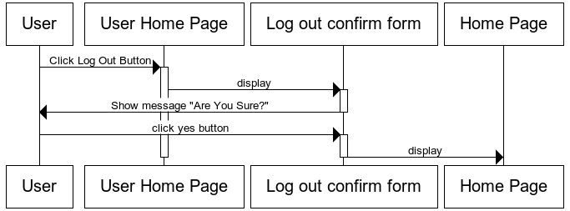

## Customer:

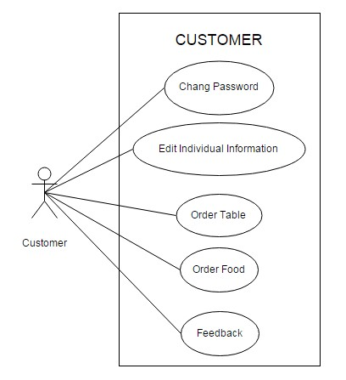

## Change Password:

|  |  |  |
| --- | --- | --- |
| **Use case name** | Change Password | |
| **Actors** | Customer | |
| **Description** | Change Password | |
| **Requirements** | Actor provides Username and Password | |
| **Pre-conditions** | Actor has logged in as Customer | |
| **Post-conditions** | Success: The password has changed. | |
| **Basic flow** | * Actor actions: * From User Home page, actor clicks * on to the ‘Change Password’ button. * Actor clicks on to ‘Save’ button to * finish adding. | * System response: * 2. System redirects to ‘Change Password’ page and display form with the following controls: * ‘Old Password’ textfield. * ‘New Password’ textfield. * ‘Confirm New Password’ textfield * ‘Save’ button. * 4. System checks input information. [Exception] * 5. System adds new Administrator into the database.. |
| **Exception** | * [Exception] * 1. Actor lefts ‘Old Password’ textfield. * 2. Actor lefts ‘New Password’textfield. * 3. Actor lefts ‘Confirm NewPassword’ textfield. * 4. ‘New Password’ textfield is not same as ‘Confirm New Password’ textfield. | * System displays a message to notice * actor: * “Old Password cannot be blank. Please input Old Password.” “New Password cannot be blank. Please input New Password.” * “Confirm New Password cannot be blank. Please input Confirm Password.” * “New Password and Confirm New * Password must be same.” |

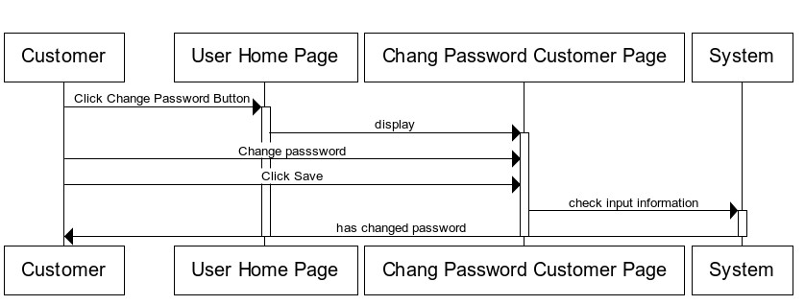

|  |  |  |
| --- | --- | --- |
| **Use Case Name** | Edit Individual Information | |
| **Actors** | Customer | |
| **Description** | Customer wants to Edit Individual Information. | |
| **Requirements** | Customer provides Customer’s information | |
| **Pre-conditions** | Actor has logged in as Customer | |
| **Post-conditions** | Success: Change Individual Information success.  Fail: Refill information. | |
| **Basic flow** | * Actor Actions: * Actor clicks ‘Update Profile’ link inUser Home page * 3. Actor inputs individual informationand click ‘Submit’ button. | 1. System Responses: 2. 2. System redirects to update Profile page and displays Update profile form with the following control : 3. - ‘UserName’ text field, read only. 4. - ‘Address’ text field 5. - ‘Phone’ text field 6. - ‘Email’ text field 7. - ‘Submit’ button 8. - ‘Cancel’ button 9. 4. System checks the information 10. [Exception] 11. 5. System edit individual information into database, show message: ‘Change Individual Information Success!’ and then redirects to User Home page. |
| **Exception** | 1. Actor Actions: 2. [Exception] 3. Actor lefts ‘Address’ text field blank. 4. Actor lefts ‘Phone’ text field blank. 5. Input phone not in numeric or phone length not in range 10 – 11 character.   4. Actor lefts ‘Email’ text field blank or input an invalid email address. | System Responses:  System displays message to Actor :  - ‘Address cannot be blank’.  - ‘Phone cannot be blank’.  - ‘The phone number should be  numeric only and must be between 10 and 11 digits’.  - ‘Email is invalid’. |

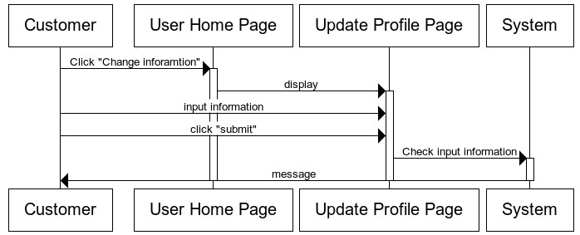

## Order Table:

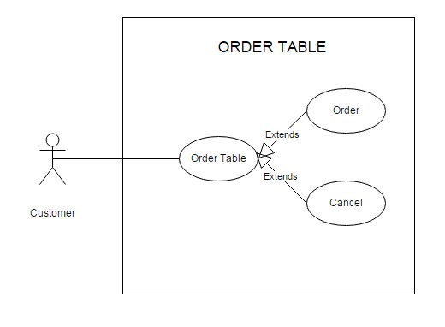

## Orderr table:

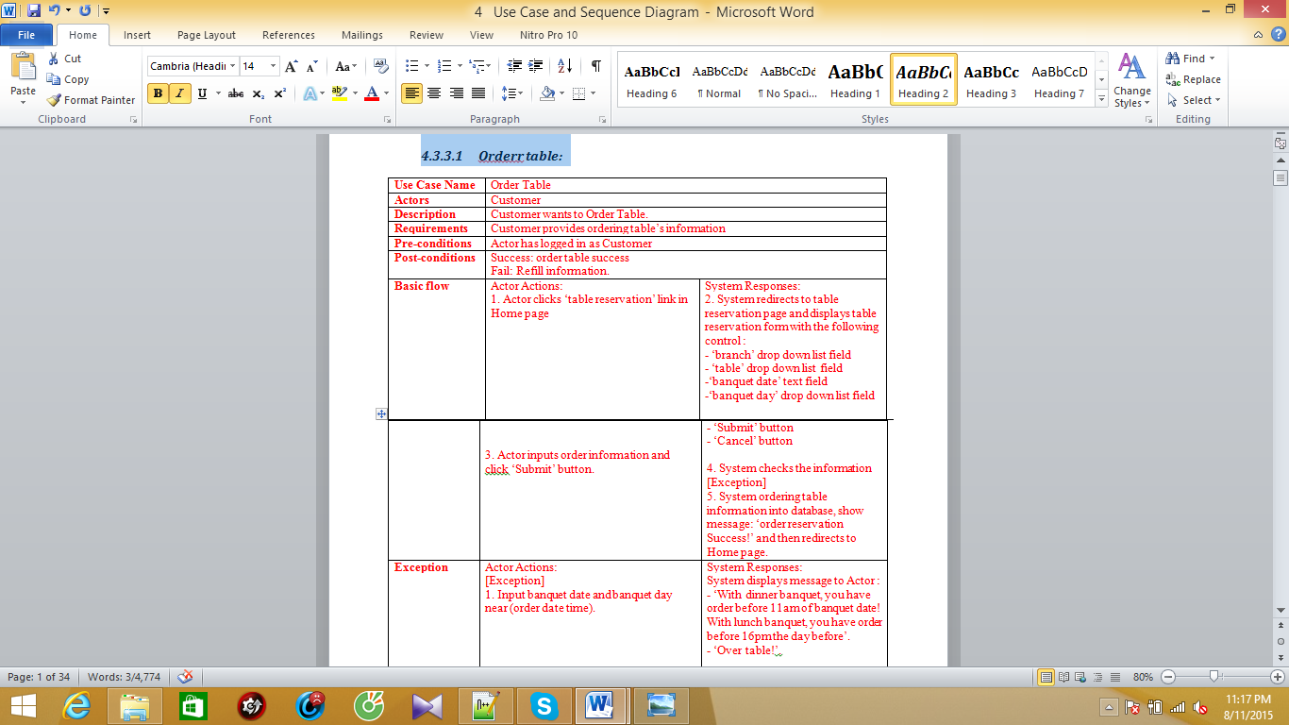

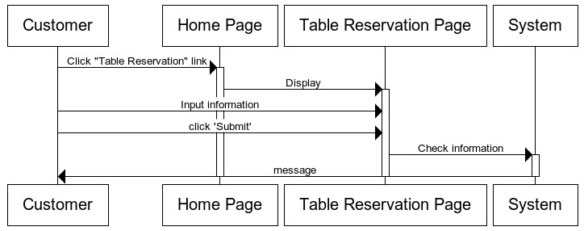

## Cancel Ordering Table:

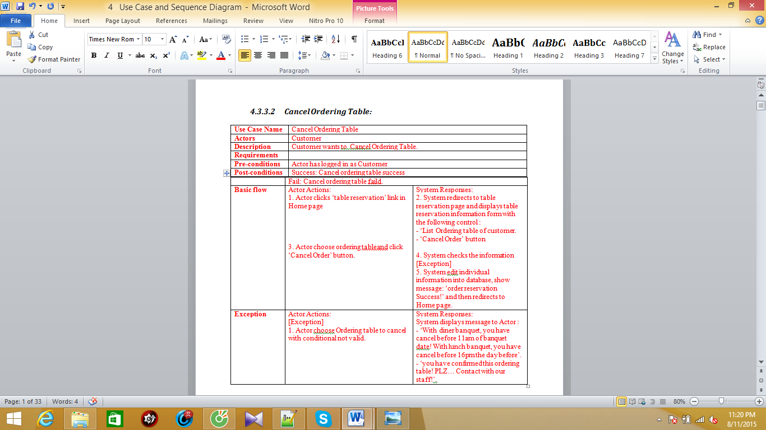

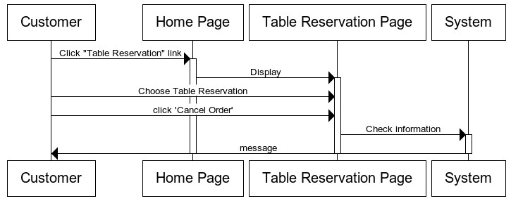

Order Food:

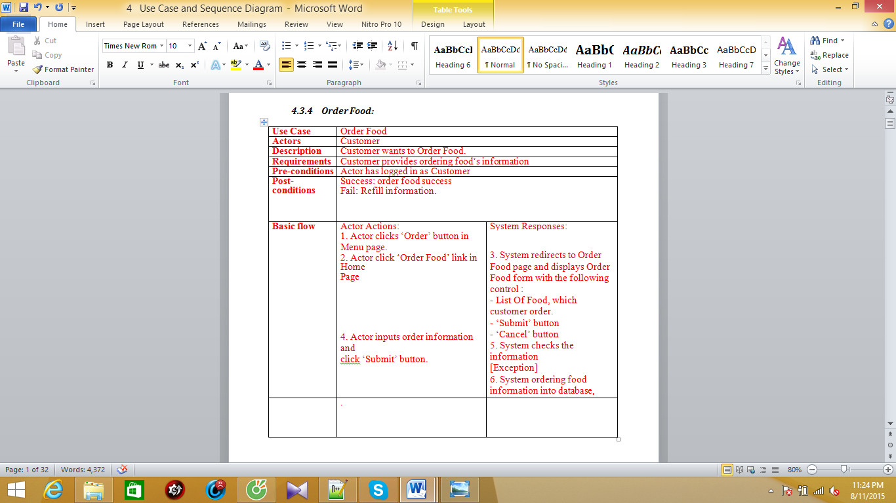

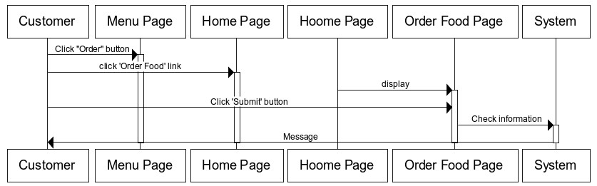

## Feedback

|  |  |  |
| --- | --- | --- |
| **Use Case Name** | Feedback | |
| **Actors** | Customer | |
| **Description** | Customer wants to Feedback. | |
| **Requirements** | Customer provides deedback’s content. | |
| **Pre-conditions** | Actor has logged in as Customer | |
| **Post-conditions** | Success: feedback success.  Fail: Refill information. | |
| **Basic flow** | Actor Actions:  1. Actor clicks ‘contact’ link in Home page  3. Actor inputs feedback’s content and  click ‘Submit’ button. | * System Responses: * 2. System redirects to feedback page and displays feedback form with the following control : * -‘content’ text field * ‘Submit’ button * ‘Cancel’ button * 4. System checks the information * [Exception] * 5. System ordering table information into database, show message: ‘Send feedback Success!’ and then redirects to Home page. |
| **Exception** | Actor Actions:  [Exception]  1. Actor lefts ‘content’ text field blank. | System Responses:  System displays message to Actor :  - ‘content cann’t be blank! ’ |

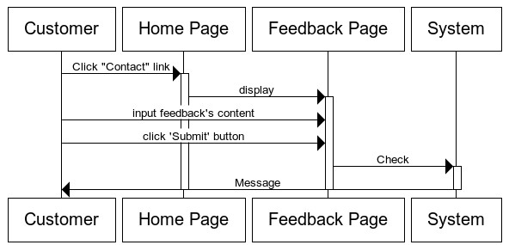

## 

## Staff:

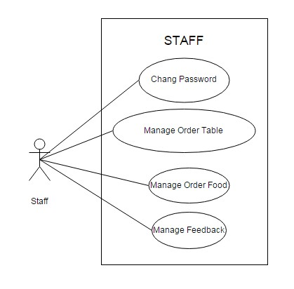

## Change Password:

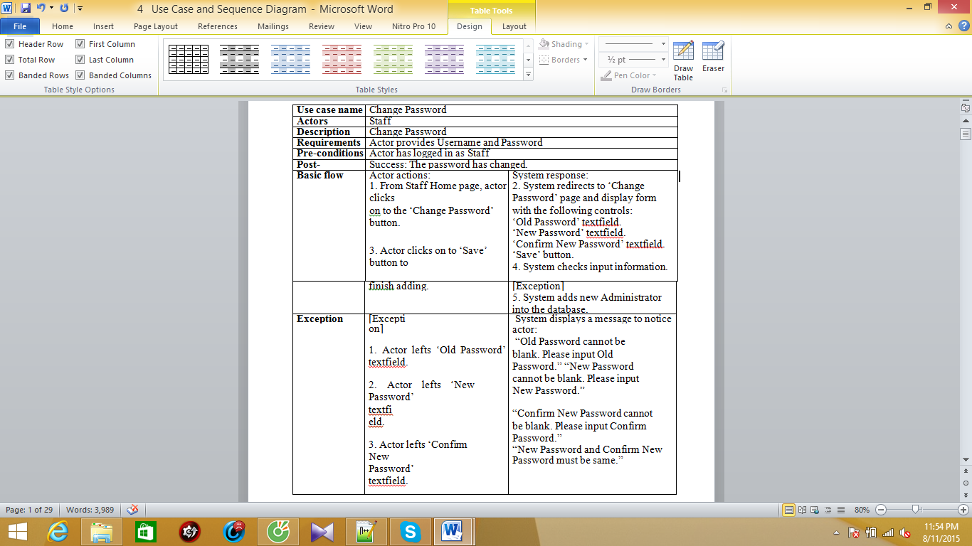

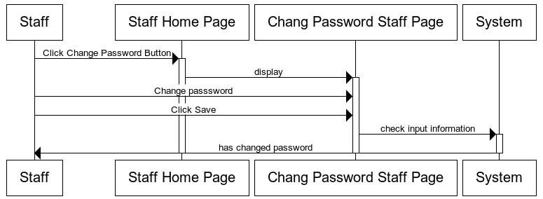

## Manage Order Food:

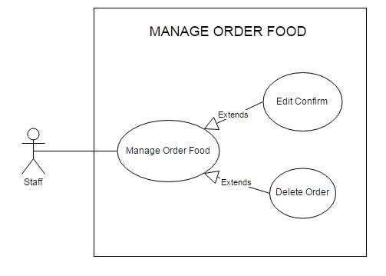

## Edit Confirm:

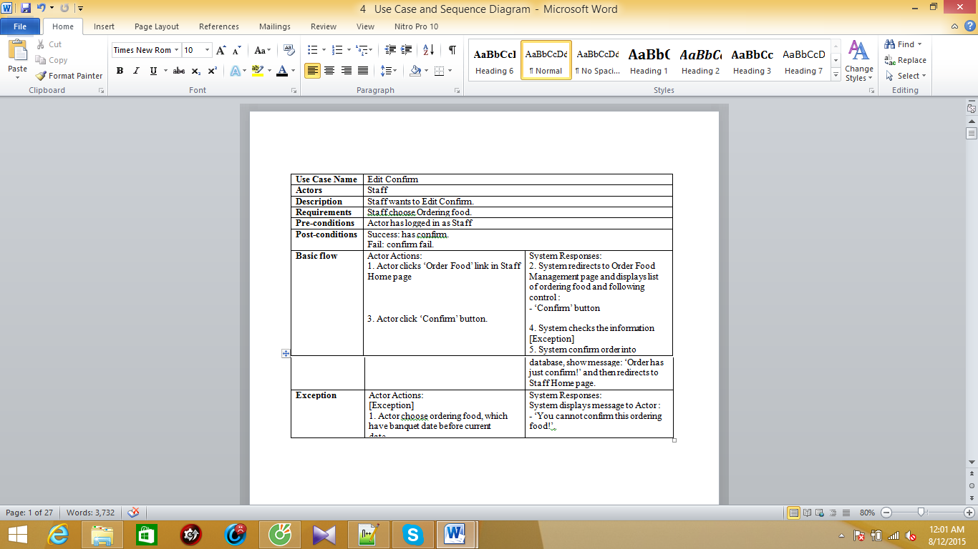

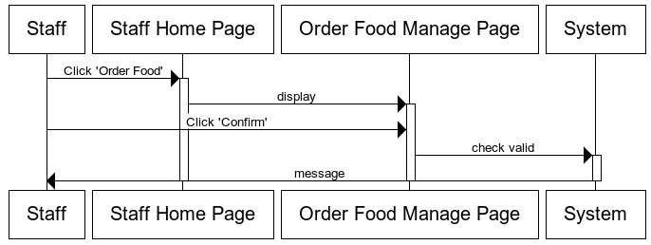

## Delete Ordering Food:

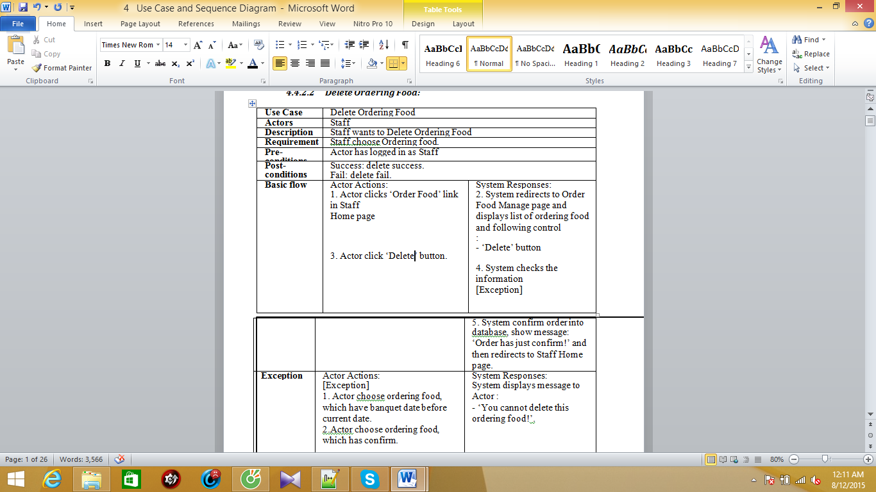

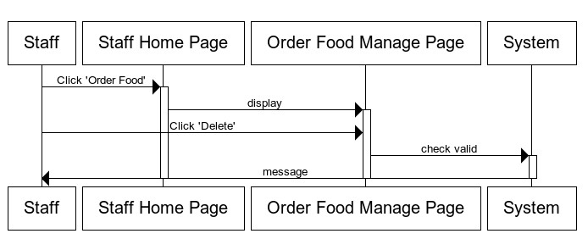

## Manage Order Table:

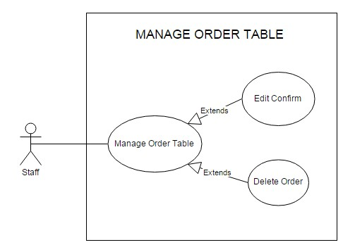

## Edit Confirm:

|  |  |  |
| --- | --- | --- |
| **Use Case Name** | Edit Confirm | |
| **Actors** | Staff | |
| **Description** | Staff wants to Edit Confirm. | |
| **Requirements** | Staff choose Ordering Table. | |
| **Pre-conditions** | Actor has logged in as Staff | |
| **Post-conditions** | Success: has confirm.  Fail: confirm fail. | |
| **Basic flow** | * Actor Actions: * Actor clicks ‘Order Table’ link in Staff * Home page * 3. Actor click ‘Confirm’ button. | * System Responses: * 2. System redirects to Order Table Manage page and displays list of ordering Table and following control : * ‘Confirm’ button * 4. System checks the information * [Exception] * 5. System confirm order into database, show message: ‘Order has just confirm!’ and then redirects to Staff Home page. |
| **Exception** | Actor Actions:  [Exception]  1. Actor choose ordering table, which have banquet date before current date. | System Responses:  System displays message to Actor :  - ‘You cannot confirm this ordering  food!’. |

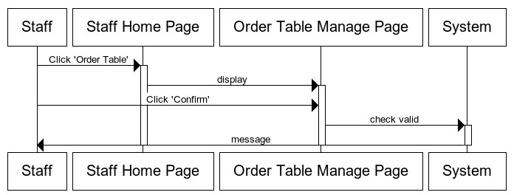

## Delete Ordering Table:

|  |  |  |
| --- | --- | --- |
| **Use Case Name** | Delete Ordering Table | |
| **Actors** | Staff | |
| **Description** | Staff wants to Delete Ordering Table | |
| **Requirements** | Staff choose Ordering table. | |
| **Pre-conditions** | Actor has logged in as Staff | |
| **Post-conditions** | Success: delete success.  Fail: delete fail. | |
| **Basic flow** | Actor Actions:  1. Actor clicks ‘Order Table’ link in Staff  Home page  3. Actor click ‘Delete’ button. | System Responses:  2. System redirects to Order Table Manage page and displays list of ordering table and following control:  - ‘Delete’ button  4. System checks the information  [Exception]  5. System confirm order into database, show message: ‘Order has just confirm!’ and then redirects to Staff Home page. |
| **Exception** | Actor Actions:  [Exception]  1. Actor choose ordering table, which have banquet date before current date.  2.Actor choose ordering table, which has confirm. | System Responses:  System displays message to Actor :  - ‘You cannot delete this ordering table!’. |

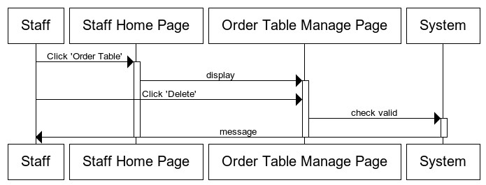

## Manage Feedback:

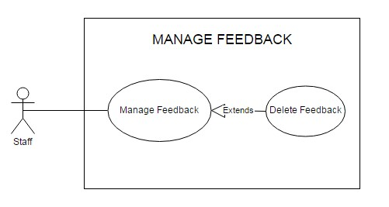

|  |  |  |
| --- | --- | --- |
| **Use Case Name** | Delete Feedback | |
| **Actors** | Staff | |
| **Description** | Staff wants to Delete Feedback | |
| **Requirements** | Staff choose Feedback. | |
| **Pre-conditions** | Actor has logged in as Staff | |
| **Post-conditions** | Success: delete success. | |
| **Basic flow** | Actor Actions:  1. Actor clicks ‘Feedback’ link in Staff  Home page  3. Actor click ‘Delete’ button. | System Responses:  2. System redirects to Feedback page and displays list of feedback and following control :  - ‘Delete’ button  4. System checks the information  5. System feedback into database, show message: ‘Delete feedback Success!’ and then redirects to Staff Home page. |

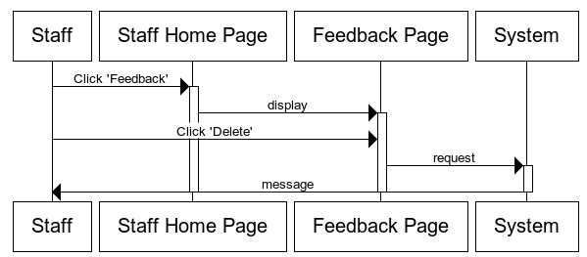

# Admin:

(Note: Management of admin include: all management of staff and private management of admin).

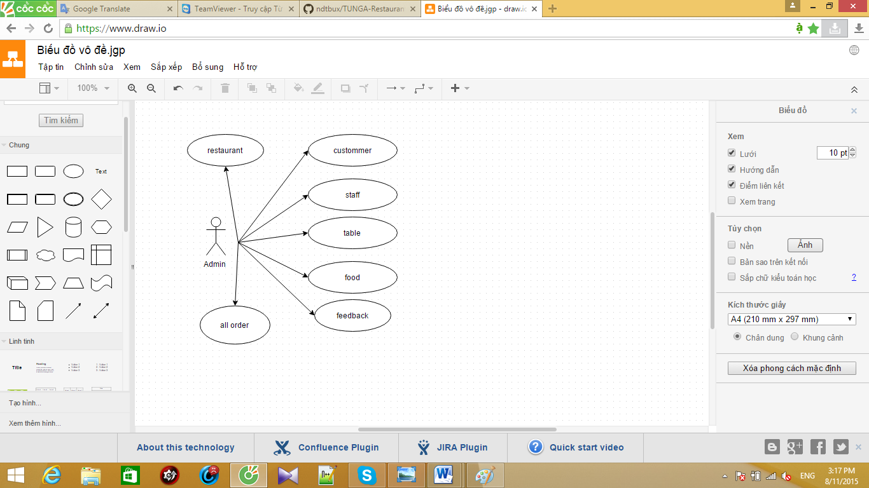

## Manage Staff:

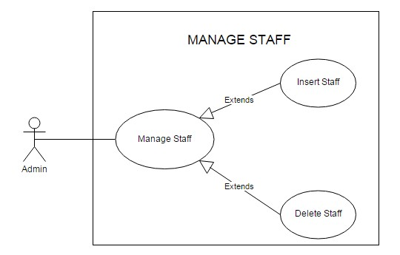

## Insert Staff:

|  |  |  |  |
| --- | --- | --- | --- |
| **Use Case Name** | Insert Staff | |  |
| **Actors** | Admin | |
| **Description** | Admin wants to insert a staff. | |
| **Requirements** | Admin provides Staff’s information | |
| **Pre-conditions** | Actor has logged in as Admin. | |
| **Post-conditions** | Success: Insert Staff Success.  Fail: Refill information | |
| **Basic flow** | Actor Actions:  1. Actor clicks ‘Staff’ link in Admin  Home page  3. Actor inputs staff’s information and  click ‘Insert’ button. | * System Responses: * 2. System redirects to Staff Management page and Insert Staff form with the following control : * ‘UserName’ text field * ‘Password’ text field * ‘Insert’ button * ‘Cancel’ button * 4. System checks the information * [Exception] * 5. System inserts the Staff into |

|  |  |  |
| --- | --- | --- |
|  |  | database, show message: ‘Insert  Staff Success!’ and then redirects to  Admin Home page. |
| **Exception** | Actor Actions:  [Exception]  1. Actor lefts ‘UserName’ text field blank.  2. UserName has already exists.  3. Actor lefts ‘Password’ text field blank. | System Responses:  System displays message to Actor :  - ‘UserName cannot be blank’.  - ‘This Username has already exist!’.  - ‘Password cannot be blank’’. |

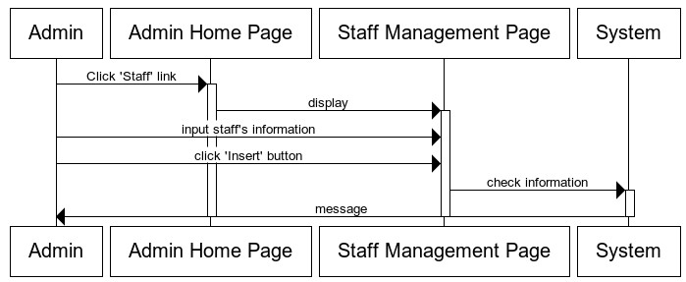

## Delete Staff:

|  |  |  |  |
| --- | --- | --- | --- |
| **Use Case Name** | Delete Staff | |  |
| **Actors** | Admin | |
| **Description** | Admin wants to Delete Staff | |
| **Requirements** | Admin choose Staff. | |
| **Pre-conditions** | Actor has logged in as Admin | |
| **Post-conditions** | Success: delete success. | |
| **Basic flow** | Actor Actions:  1. Actor clicks ‘Staff’ link in Admin  Home page  3. Actor click ‘Delete’ button. | System Responses:  2. System redirects to Staff Management page and displays list of Staff and following control :  ‘Delete’ button  4. System checks the information  System save into database, show  message: ‘Delete Success!’ and then redirects to Admin Home page. |

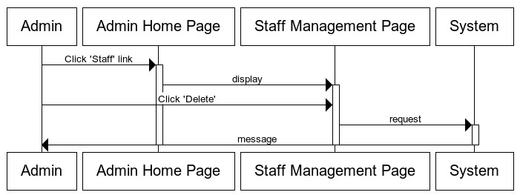

## 

## Manage restaurant:

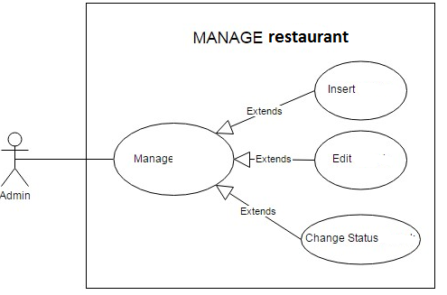

## 

## Insert restaurant:

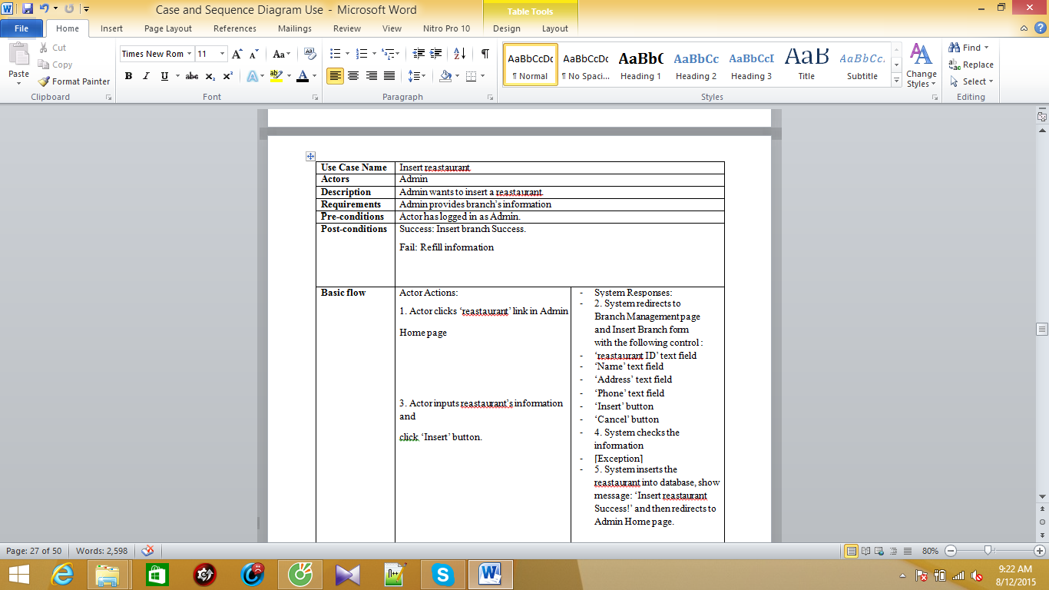

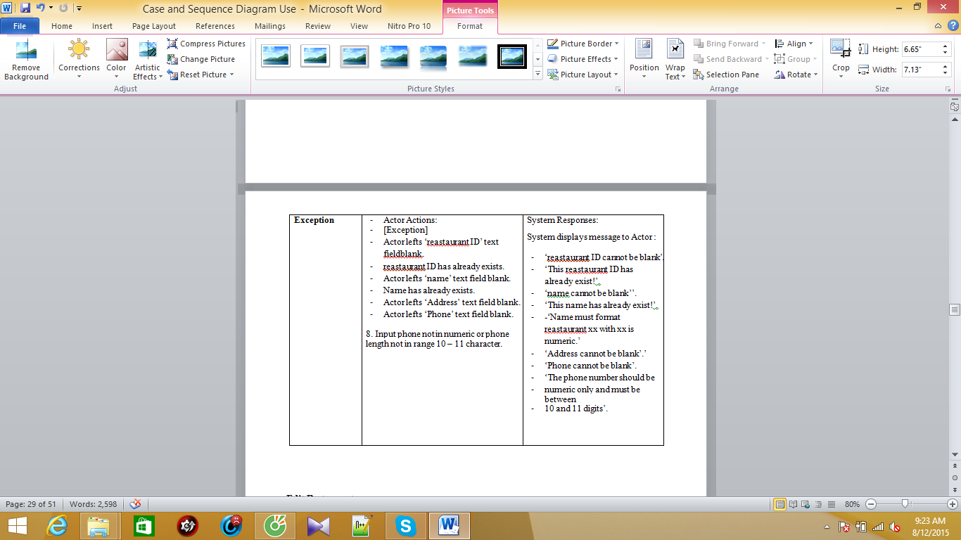

## Edit Restaurant:

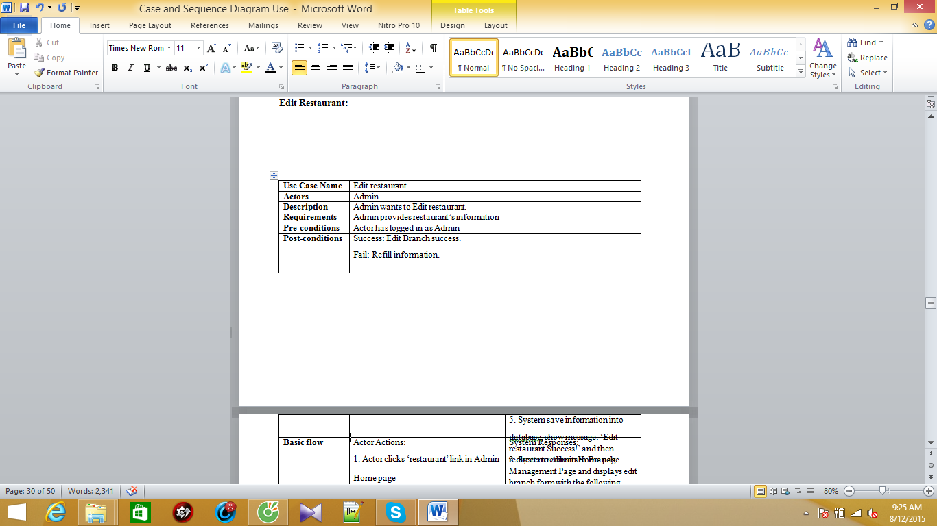

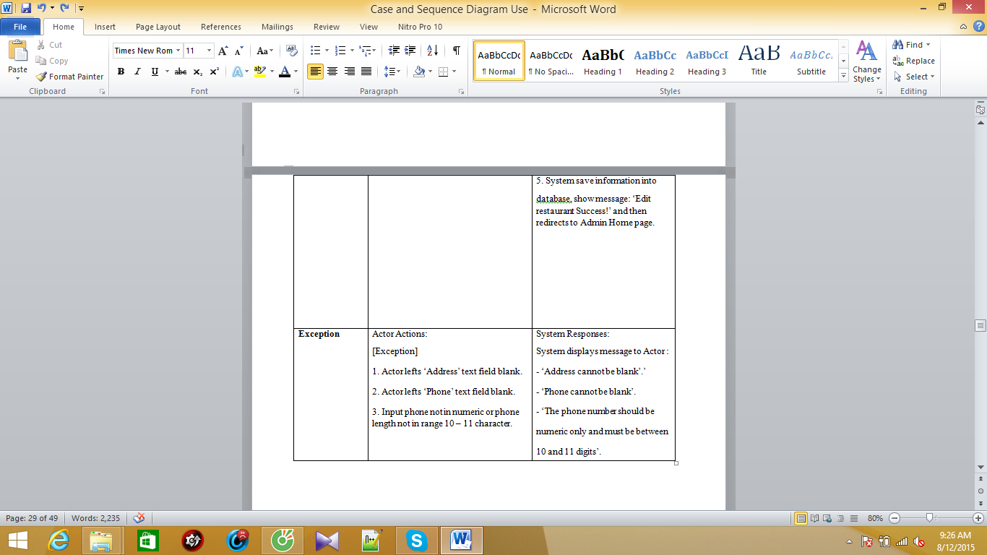

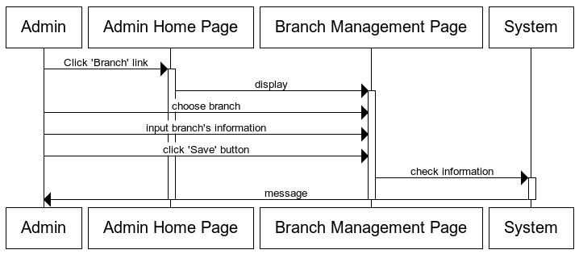

## Change Status restaurant:

|  |  |  |  |
| --- | --- | --- | --- |
| **Use Case Name** | Change Status Branch | |  |
| **Actors** | Admin | |
| **Description** | Admin wants to change status of restaurant. | |
| **Requirements** | Admin choose restaurant. | |
| **Pre-conditions** | Actor has logged in as Admin | |
| **Post-conditions** | Success: change status branch success. | |
| **Basic flow** | Actor Actions:  1. Actor clicks ‘restaurant’ link in Admin  Home page  Actor click ‘Active’ button or ‘Not  Active’ button | System Responses:  2. System redirects to restaurant Management Page and change status branch form with the following control :  if restaurant is active, ‘not active’  button display.  - if restaurant is not active, ‘active’  button display.  4. System checks the information  5. System save information into database, show message: ‘Change Status Success!’ and then redirects to Admin Home page |

## Manage Room:

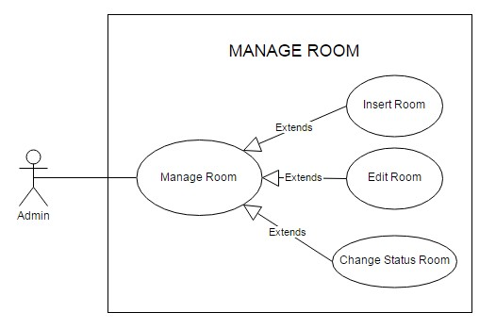

## Insert table:

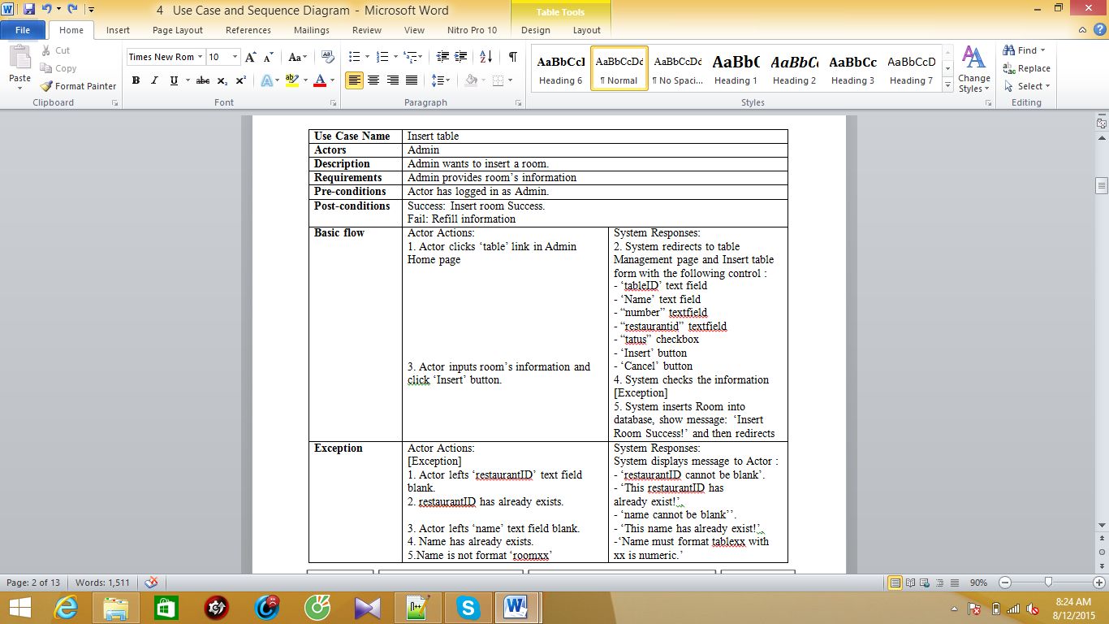

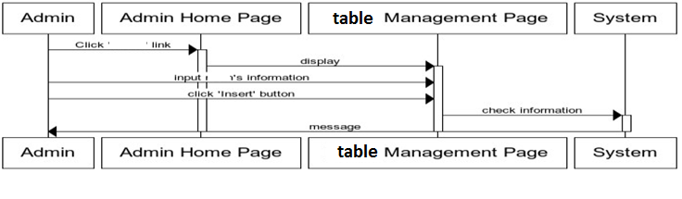

## Edit table:

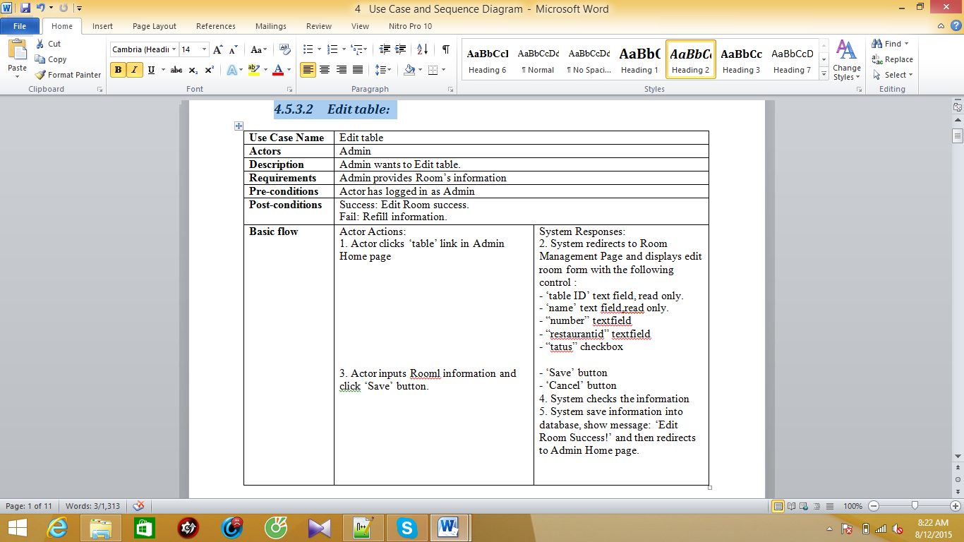

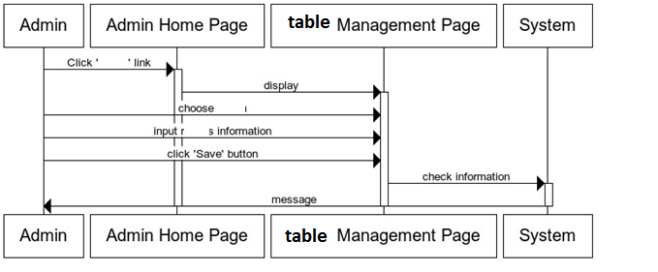

## Change Status table:

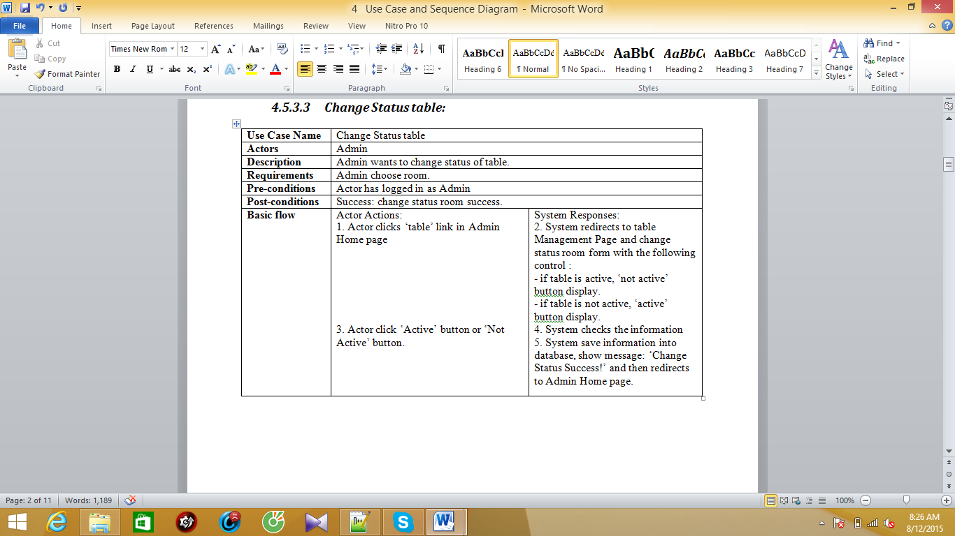

## Manage Room:



## Change Status table:

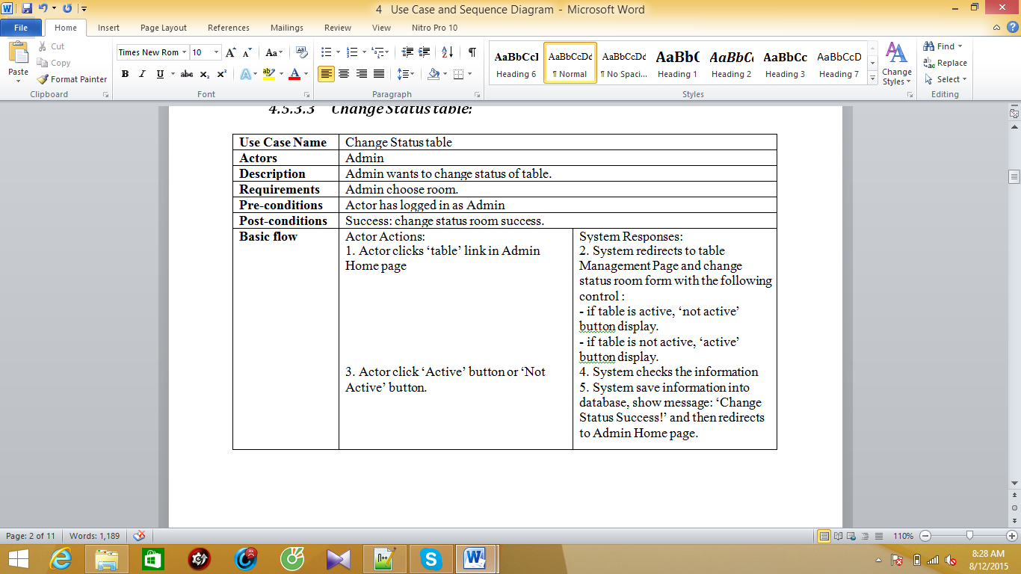

## Manage Category Food:

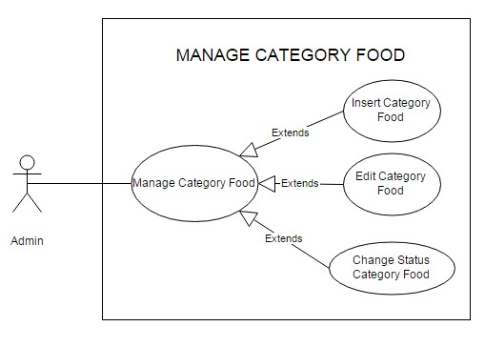

## Insert Category Food:

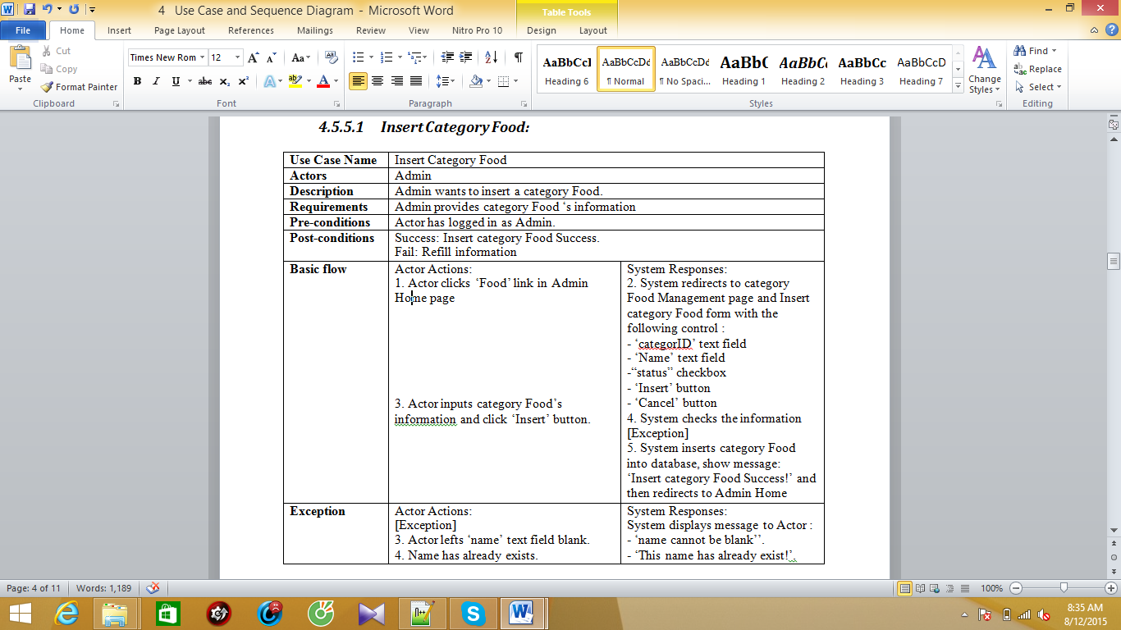

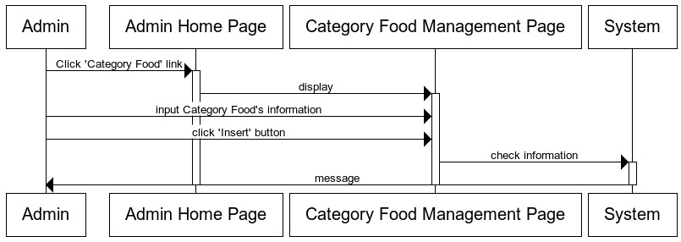

## Manage Room:



## Change Status table:

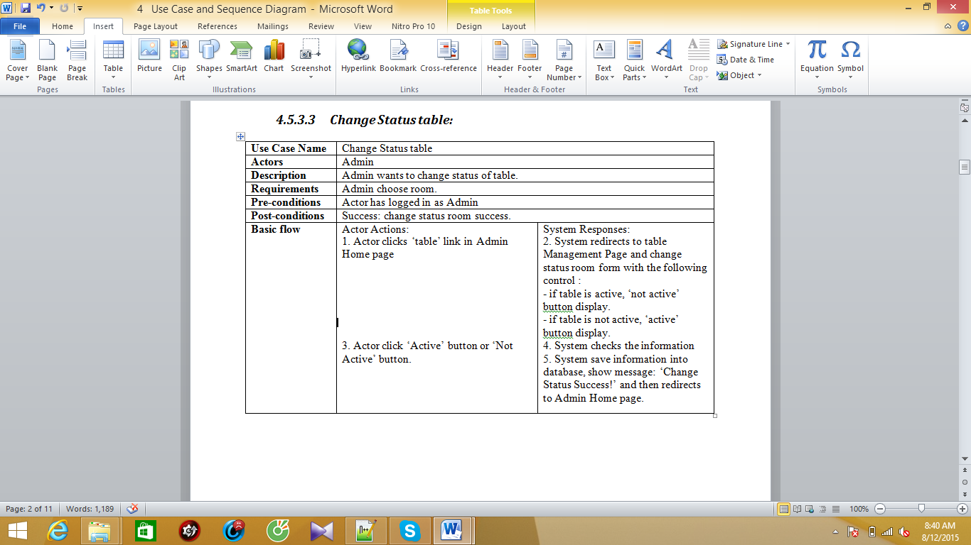

## Manage Category Food:



## Insert Category Food:

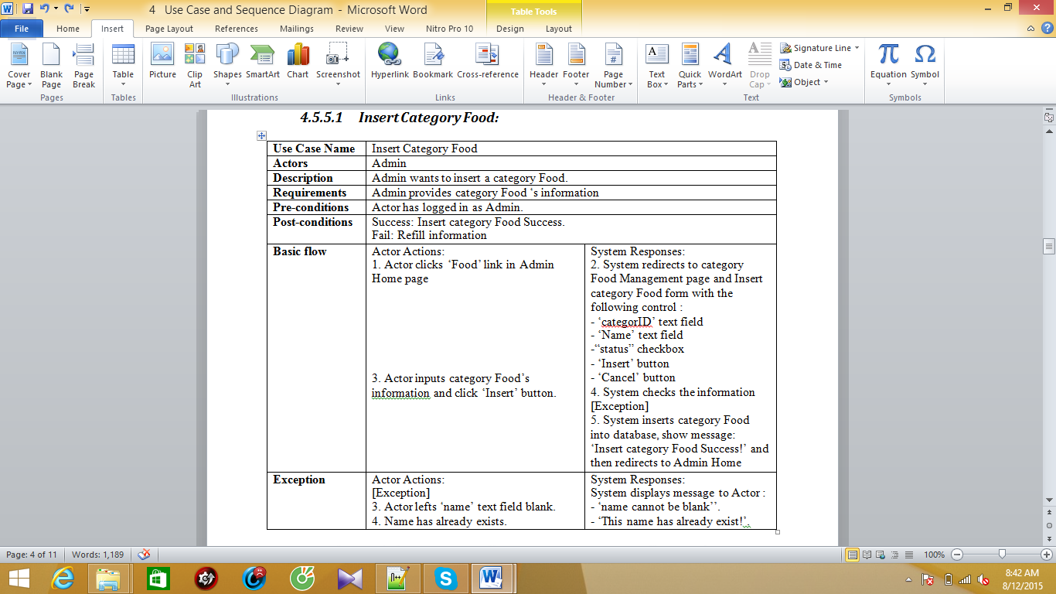



## Edit Category Food:

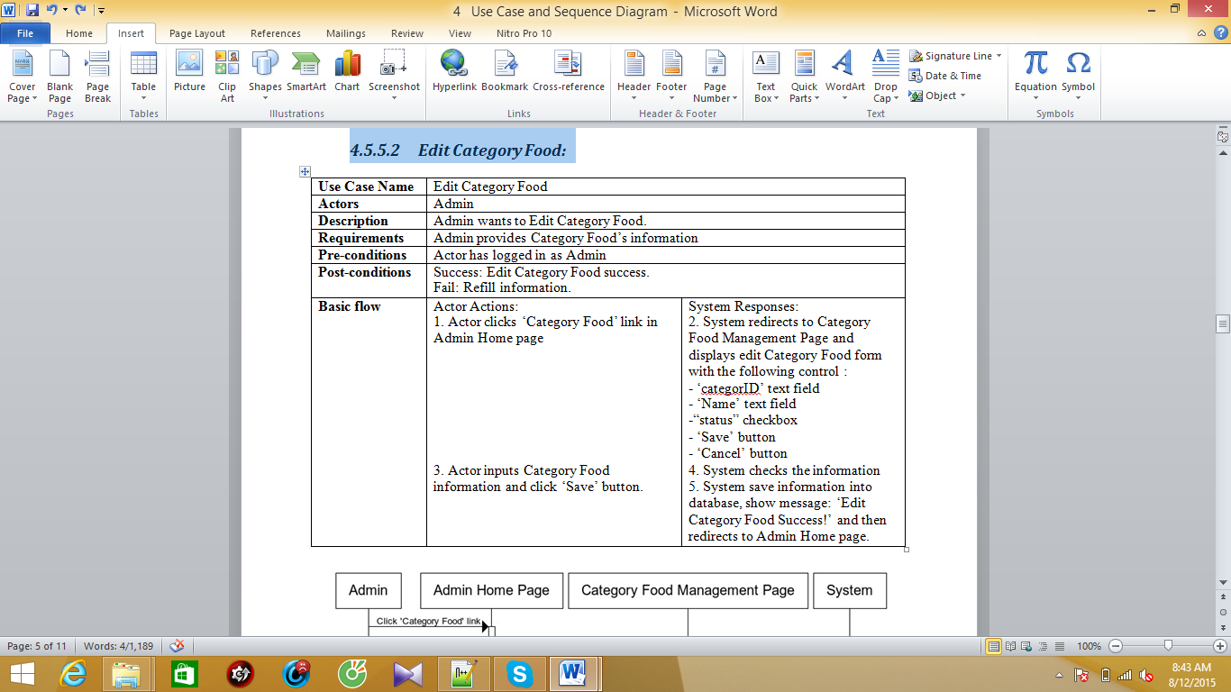

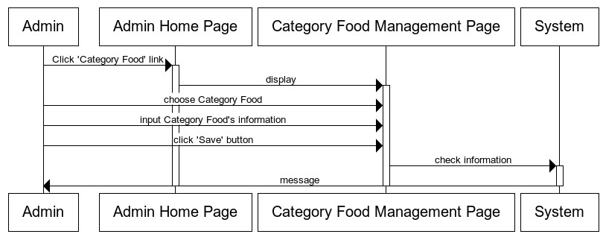

## Change Status Category Table:

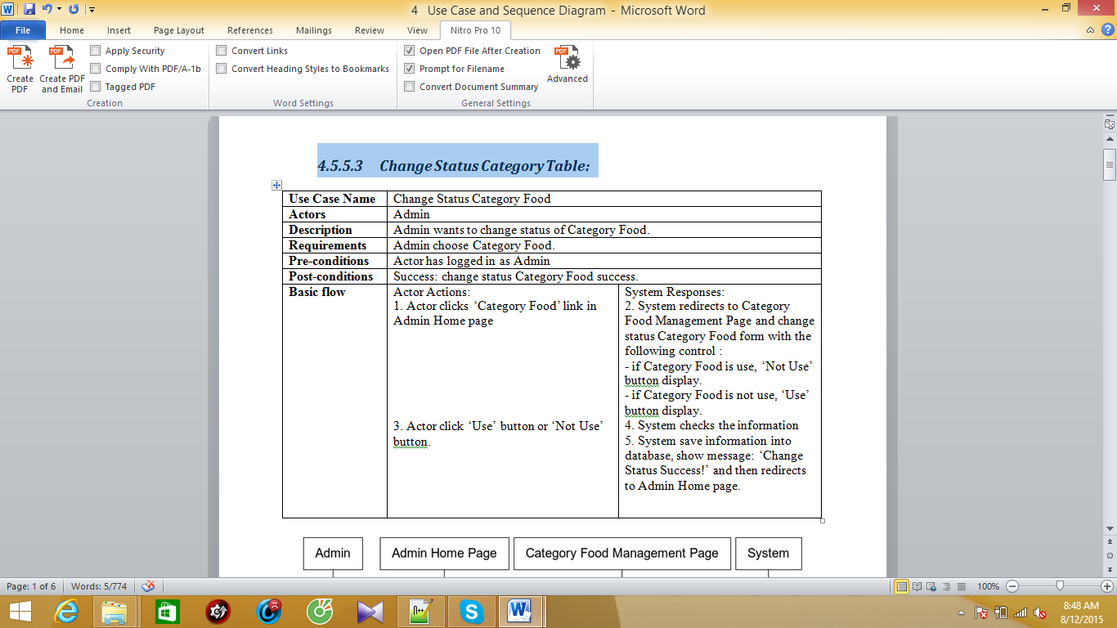

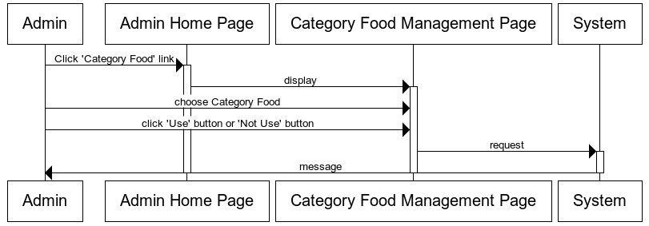

## Manage Food:

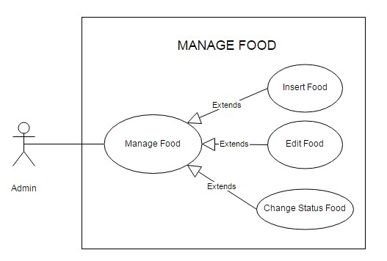

## Insert Food:

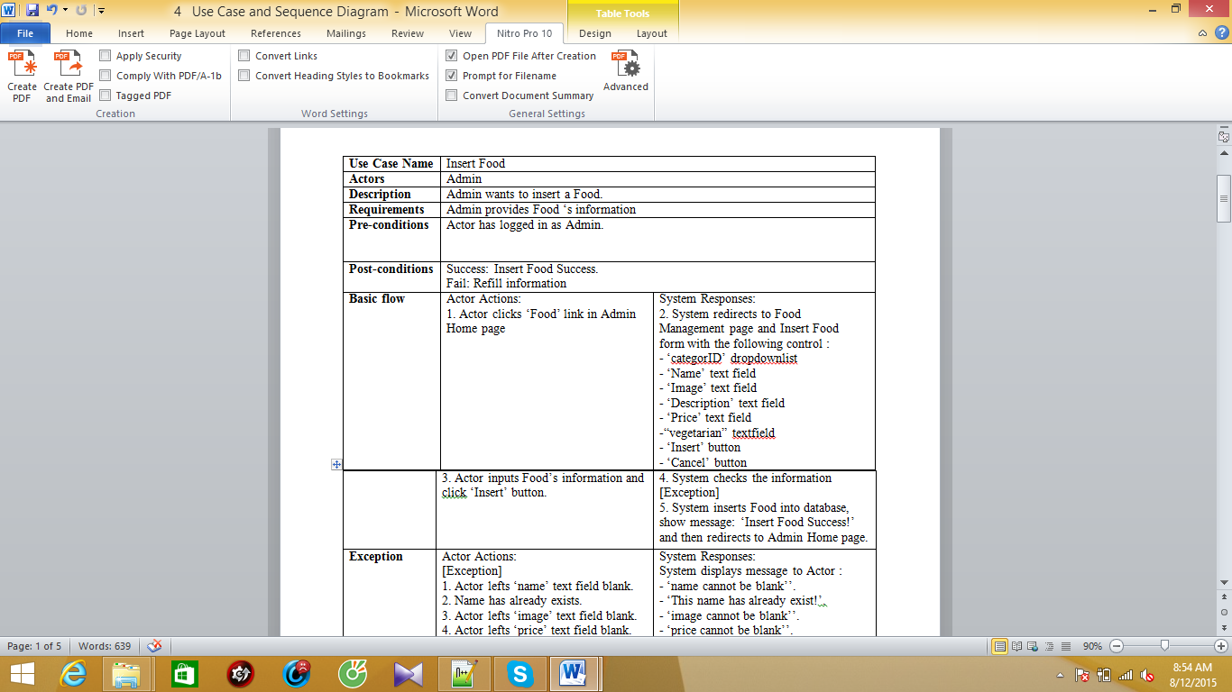

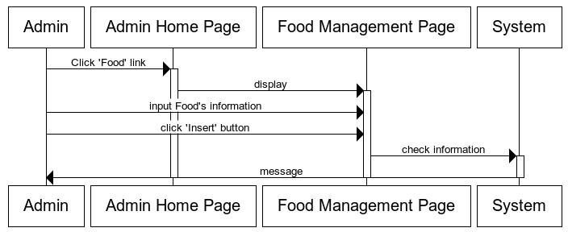

## Edit Category Food:

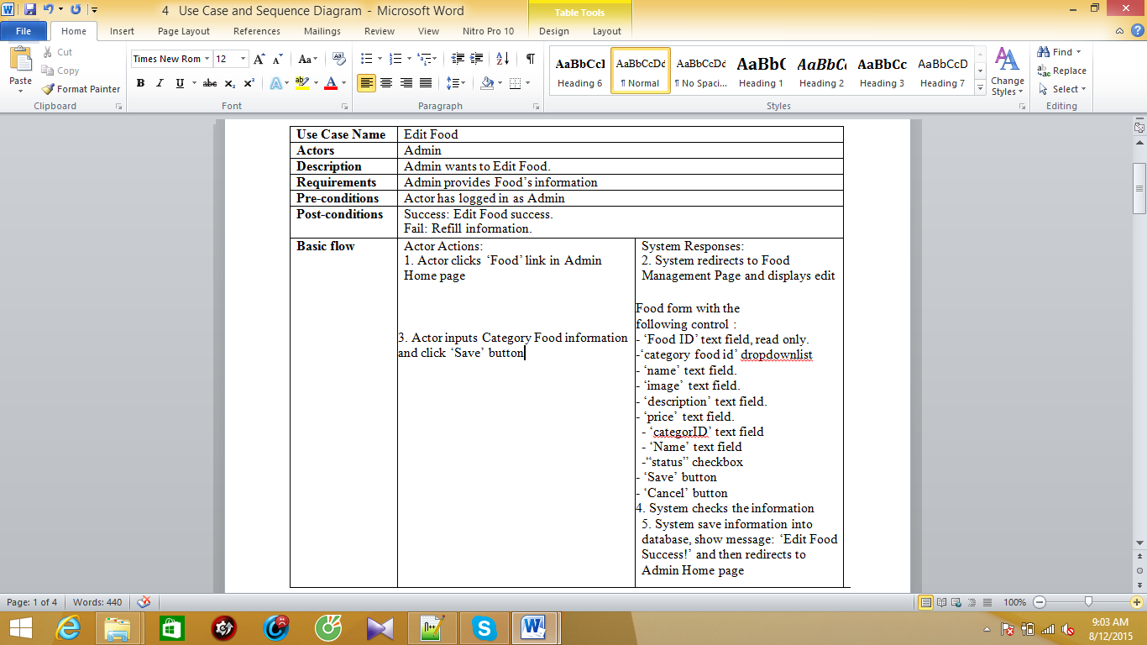

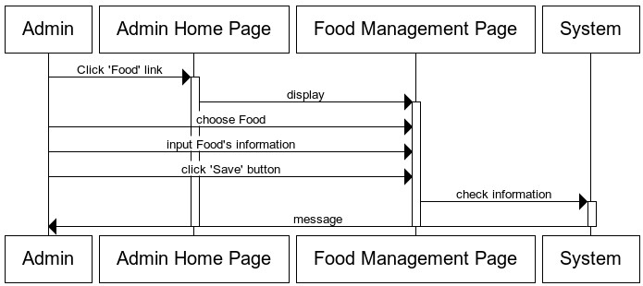

## Change Status Food:

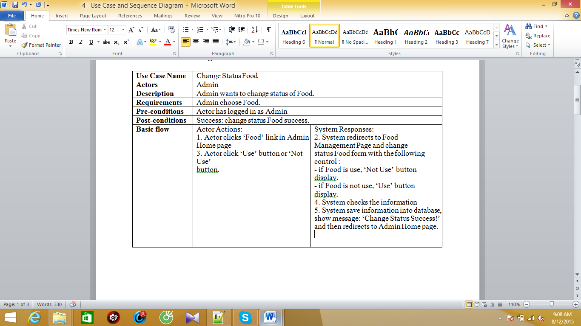

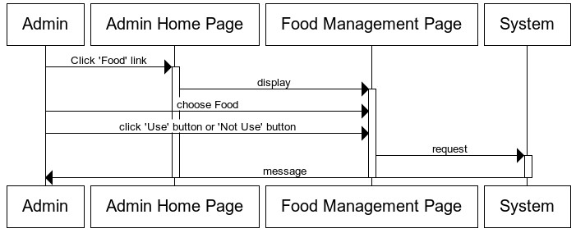

## Manage Customer:

